Predicting Bike Rental
Sudipta Mandal
24 July 2019

Contents

1 | Introduction |  |  | 3
 | 1.1 | Problem Statement . . . . . . . . . . . . . . . . . . . . . . . . . . . . . . . . . . . . . . . . . . |  | 3
 | 1.2 | Data . | . . . . . . . . . . . . . . . . . . . . . . . . . . . . . . . . . . . . . . . . . . . . . . . . . | 4
2 | Methodology |  |  | 5
 | 2.1 | Pre-processing Techniques. . . . . . . . . . . . . . . . . . . . . . . . . . . . . . . . . . . . . . . . . .. . |  | 5
 |  | 2.1.1 | Univariate Analysis . . . . . . . . . . . . . . . . . . . . . . . . . . . . . . . . . . . . . . . | 5
 |  | 2.1.2 | Multivariate Selection . . . . . . . . . . . . . . . . . . . . . . . . . . . . . . . . . . . . . . . | 9
 |  | 2.2.1 | Missing value analysis | 10
 |  | 2.2.2 | Outlier analysis | 10
 |  | 2.2.3 | Feature Selection | 13
 |  | 2.2.4 | Feature Scaling | 14
3 | Modelling |  |  | 15
 | 3.1 | Model Selection . . . . . . . . . . . . . . . . . . . . . . . . . . . . . . . . . . . . . . . . . . . |  | 15
 |  | 3.1.1 Evaluating Regression Model . . . . . . . . . . . . . . . . . . . . . . . . . . . . . . . . |  | 15
 | 3.2 | Decision Tree . . . . . . . . . . . . . . . . . . . . . . . . . . . . . . . . . . . . . . . . . .. . |  | 16
 | 3.3 | Random Forest |  | 17
 | 3.4 | Linear Regression . . . . . . . . . . . . . . . . . . . . . . . . . . . . . . . . . . . . . . . . . .. . |  | 19
Appendix A - R Code |  |  |  | 21
 |  | Univariate Analysis (Fig: 2.1 & 2.2 & 2.3) . . . . . . . . . . . . . . . . . . . . . . . . . . . . . . |  | 21
 |  | Bivariate Analysis (Fig: 2.4) . . . . . . . . . . . . . . . . . . . . . . . . . . . |  | 22
 |  | Outlier Analysis (Fig: 2.5 & 2.6) . . . . . . . . . . . . . . . . . . . . . . . . . . . . |  | 22
 |  | Complete R File . . . . . . . . . . . . . . . . . . . . . . . . . . . . . . . . . . . . . |  | 23

Chapter 1

Introduction

  - Problem Statement
The Bike Rental Data consists the daily count of rental bikes between the year 2011 and 2012 based on weather and seasonal settings. We would like to predict the daily count of rental count in order to automate the system.

  - Data
Our task is to build Regression model which will give the daily count of rental bikes based on weather and season Given below is a sample of the data set that we are using to predict the count:

Table 1.1: Bike Rental Sample Data (Columns: 1-8)

instant | dteday | season | Yr | mnth | holiday | weekday | workingday
1 | 01-01-2011 | 1 | 0 | 1 | 0 | 6 | 0
2 | 02-01-2011 | 1 | 0 | 1 | 0 | 0 | 0
3 | 03-01-2011 | 1 | 0 | 1 | 0 | 1 | 1
4 | 04-01-2011 | 1 | 0 | 1 | 0 | 2 | 1
5 | 05-01-2011 | 1 | 0 | 1 | 0 | 3 | 1

Table 1.2: Bike Rental Sample Data (Columns: 9-16)

weathersit | temp | atemp | Hum | windspeed | casual | registered | cnt
2 | 0.344167 | 0.363625 | 0.805833 | 0.160446 | 331 | 654 | 985
2 | 0.363478 | 0.353739 | 0.696087 | 0.248539 | 131 | 670 | 801
1 | 0.196364 | 0.189405 | 0.437273 | 0.248309 | 120 | 1229 | 1349
1 | 0.2 | 0.212122 | 0.590435 | 0.160296 | 108 | 1454 | 1562
1 | 0.226957 | 0.22927 | 0.436957 | 0.1869 | 82 | 1518 | 1600

As you can see in the table below we have the following 14 variables, using which we have to correctly predict the count of bike rentals

Table 1.3: Bike Rental Predictors

s.no | Variables
1 | Dteday
2 | Season
3 | Yr
4 | Mnth
5 | Holiday
6 | Weekday
7 | Workingday
8 | Weathersit
9 | Temp
10 | Atemp
11 | Hum
12 | Windspeed
13 | Casual
14 | Registered

Chapter 2

Methodology

2.1 Pre Processing

Any predictive modelling requires that we look at the data before we start modelling. However, in data mining terms looking at data refers to so much more than just looking. Looking at data refers to exploring the data, cleaning the data as well as visualizing the data through graphs and plots. This is often called as Exploratory Data Analysis. To start this process, we will first try and look at all the probability distributions of the variables. Most analysis like regression, require the data to be normally distributed. We can visualize that in a glance by looking at the probability distributions or probability density functions of the variable.

2.1.1 Univariate Analysis

In Figure 2.1 and 2.2 we have plotted the probability density functions numeric variables present in the data including target variable cnt.

- Target variable cnt is normally distributed

- Independent variables like ‘temp’,’atemp’,’windspeed’ and ‘registered’ data is distributed normally.

- Independent variable ‘casual’ data is slightly skewed to the right so, there is chances of getting outliers.

- Other Independent variable ‘hum’ data is slightly skewed to the left, here data is already in normalize form so outliers are discarded.

Figure 2.1 Distribution of target variable (CNT) (R code in Appendix A)

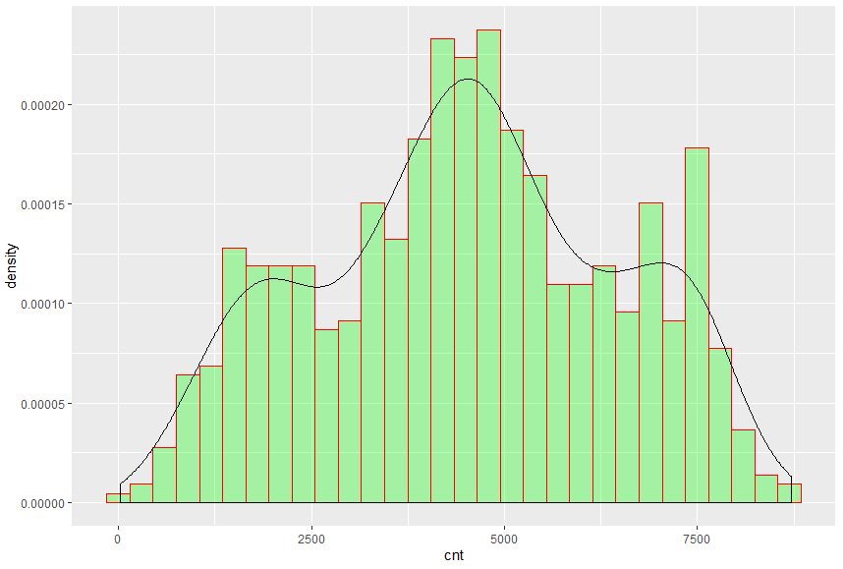
Figure 2.2 showing distribution of dependent variables (R code in Appendix A)

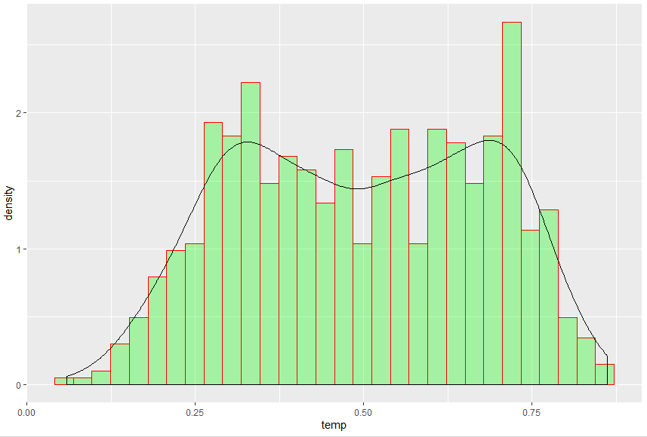

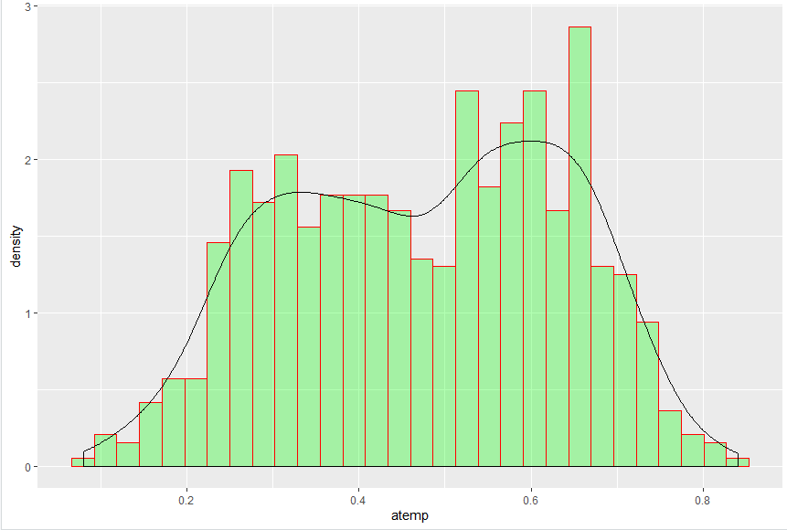

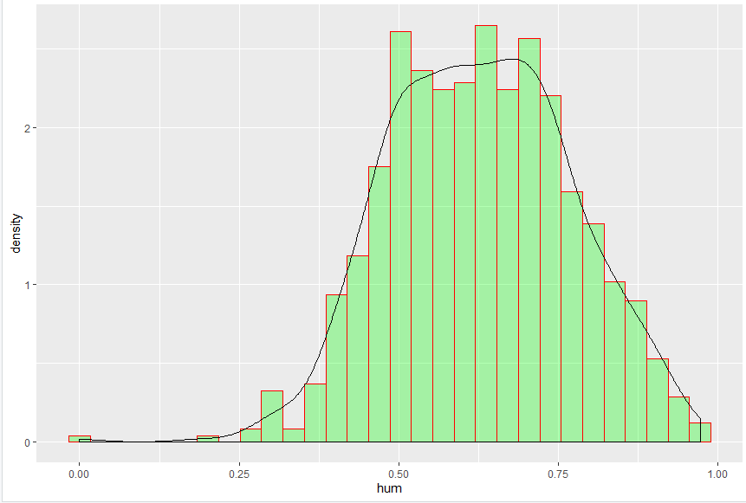

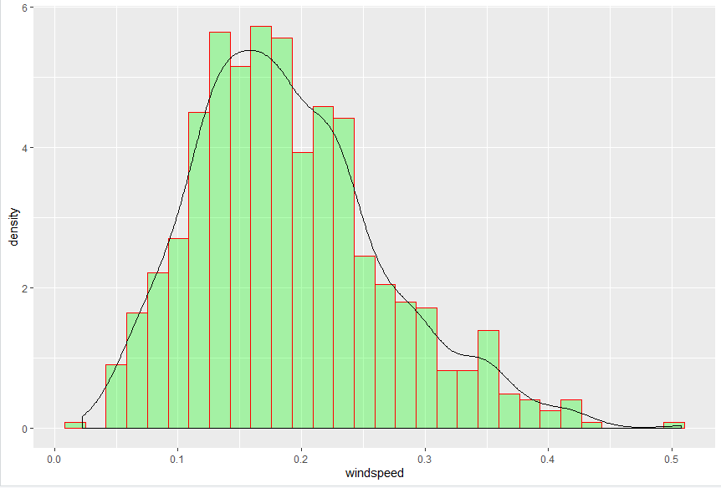

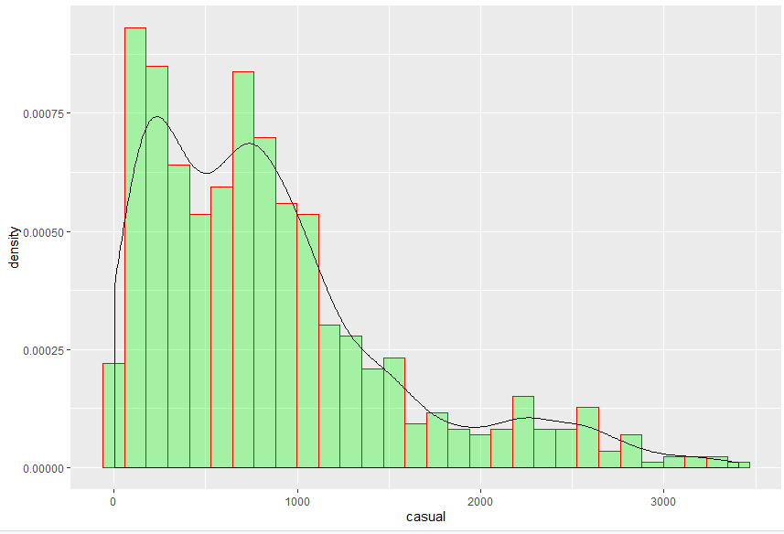

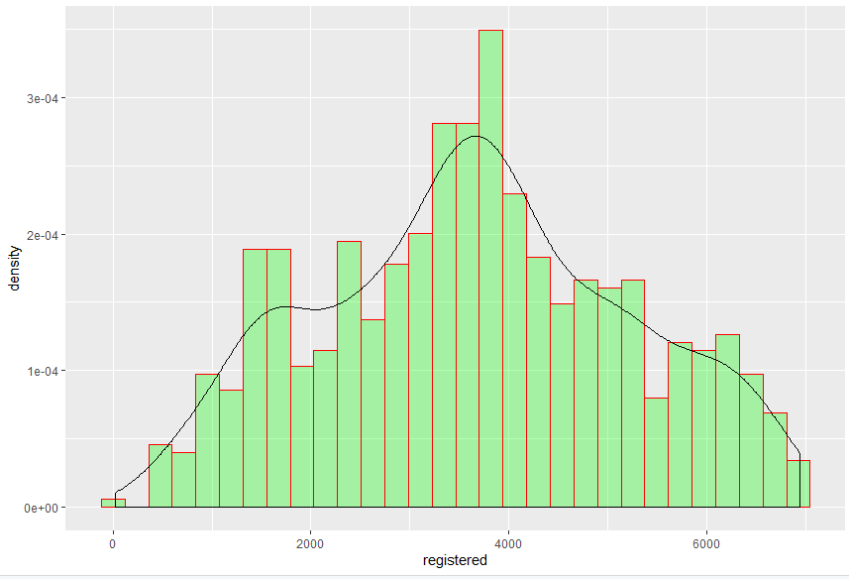

In figure 2.3 we have plotted the visualization for categorical variables and found the below observations:

- the visualization is showing that almost all the bike rentals are happening on holidays

- the visualization is showing bike rental counts are same on all weekdays

- bike rental count is more when weather is " Clear, Few clouds, Partly cloudy, Partly cloudy"

Figure 2.3 showing visualization of categorical variables (R code in Appendix A)

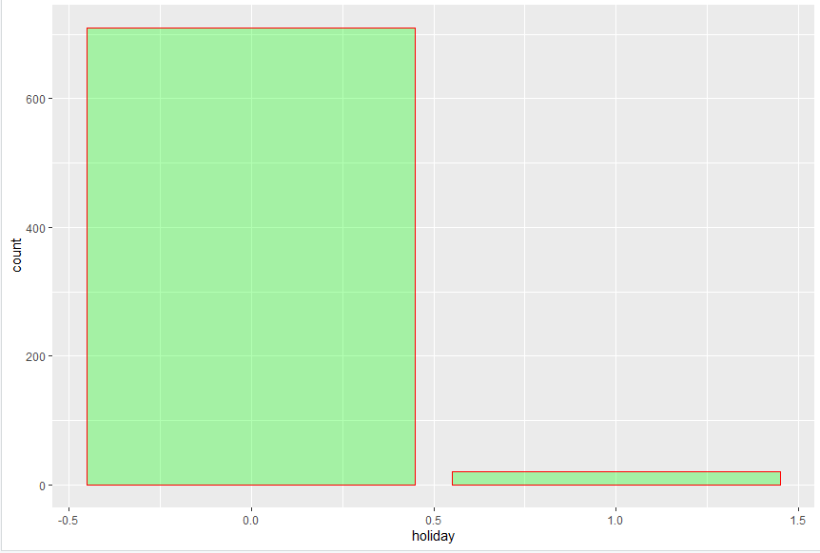

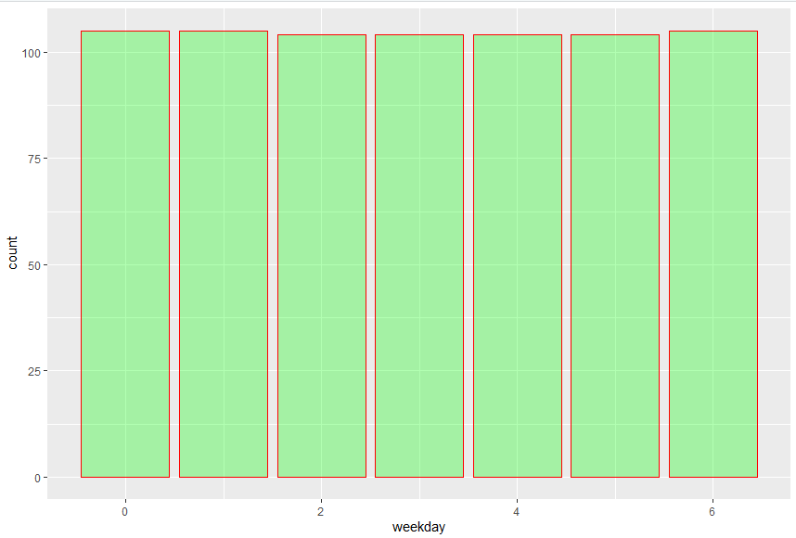

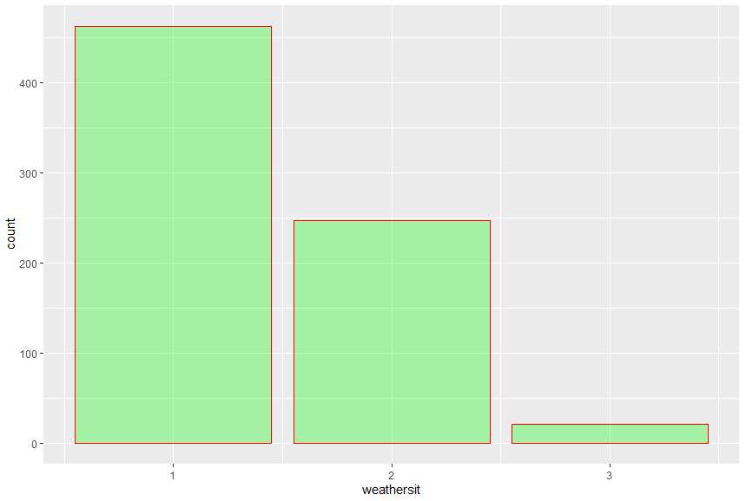

2.1.2 Multivariate Analysis

Ggpair function built upon ggplot2, GGally provides templates for combining plots into a matrix through the ggpairs function. Such a matrix of plots can be useful for quickly exploring the relationships between multiple columns of data in a data frame.
Below figures shows relationship between independent variables and also with numeric target variable using ggpair
- Below ggpair graph is showing clearly that relationship between independent variables ‘temp’ and ‘atemp’ are very strong.
- The relationship between ‘hum’ , ‘windspeed’ with target variable ‘cnt’ is less.

Figure 2.4 relationship between numeric variables (R code in Appendix A)

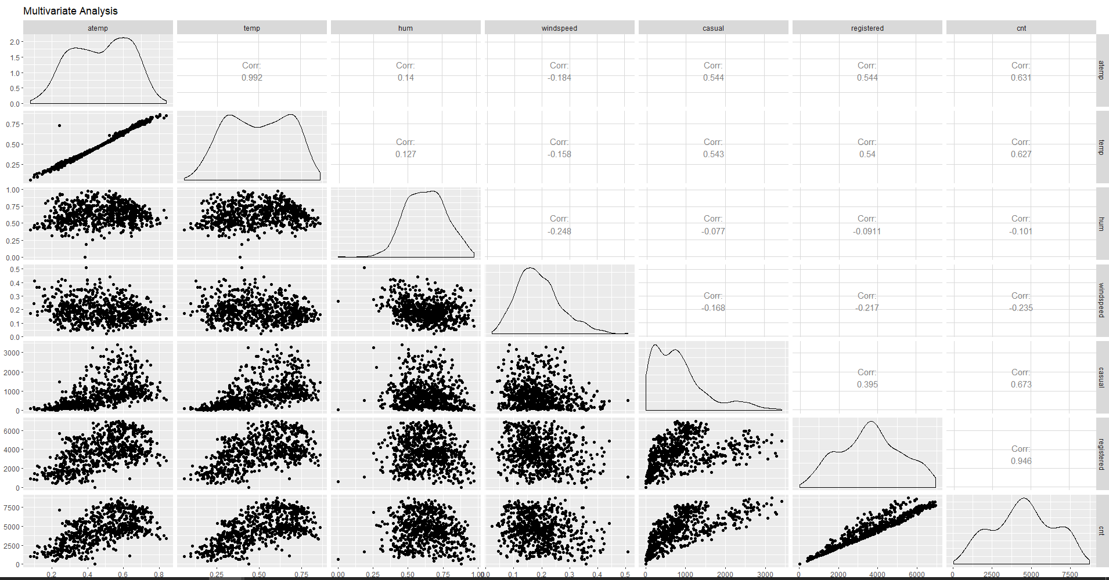
2.2.1 Missing Value Analysis
Missing values in data is a common phenomenon in real world problems. Knowing how to handle missing values effectively is a required step to reduce bias and to produce powerful models.
Below table illustrate no missing value present in the data.

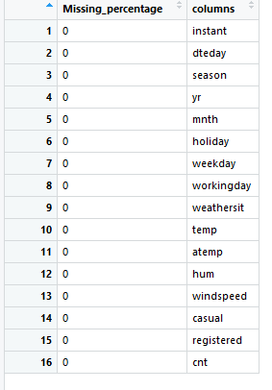

2.2.2 Outlier Analysis

One of the other steps of pre-processing apart from checking for normality is the presence of outliers; an outlier is an observation point that is distant from other observations. Outliers in data can distort predictions and affect the accuracy, if you don’t detect and handle them appropriately especially in regression models.
As we are observed in fig 2.2 the data is skewed so, there is chance of outlier in independent variable ‘casual’, one of the best method to detect outliers is Boxplot
Fig 2.5 shows presence of Outliers in variable ‘casual’ and relationship between ‘casual’ and ‘cnt’ before removing Outliers
Fig 2.6 shows boxplot of ‘casual’ after removing outliers and relationship between ‘casual’ and ‘cnt’ after removing outliers

Figure 2.5 ‘casual’ Boxplot and relation between ‘cnt’ and’ casual’ before treat outliers (R code in Appendix A)

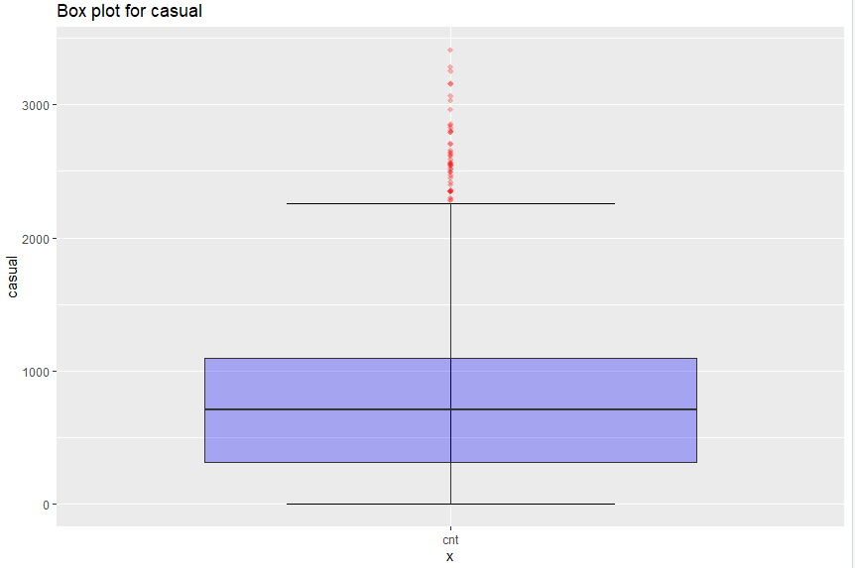

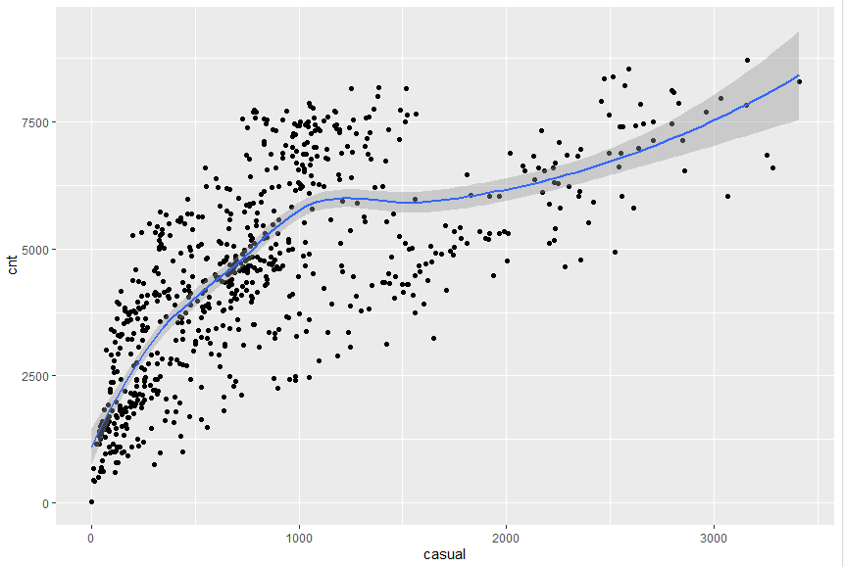

Figure 2.6 ‘casual’ Boxplot and relation between ‘cnt’ and’ casual’ before treat outliers (R code in Appendix A)

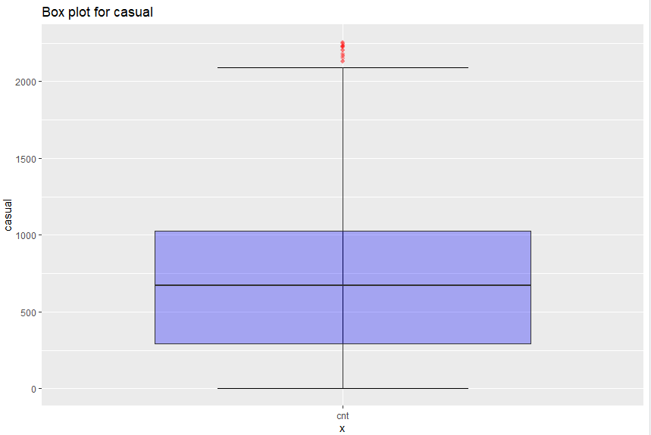

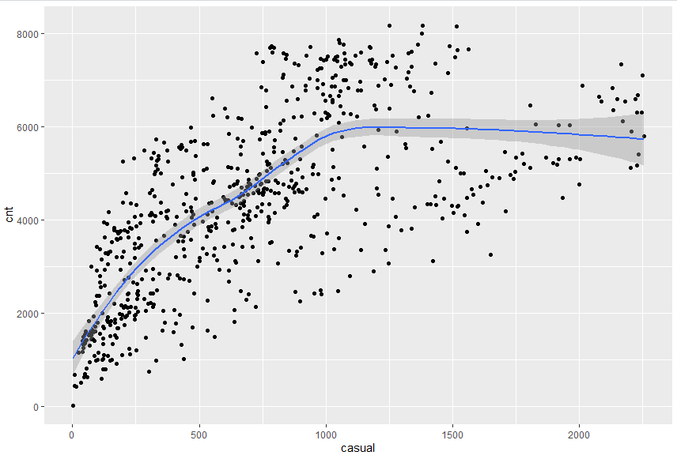

Since there is significant difference between Pearson coefficient correlation between before and after outlier detection for ‘casual’ and ‘cnt’ and losing nearly 40 observations so, we are not going to treat the outliers.

2.2.3 Features Selections

Before performing any type of modeling we need to assess the importance of each predictor variable in our analysis. There is a possibility that many variables in our analysis are not important at all to the problem of class prediction. There are several methods of doing that.

We should consider the selection of feature for model based on below criteria
- The relationship between two independent variables should be less and
- The relationship between Independent and Target variables should be high.
Below fig 2.6 illustrates that relationship between all numeric variables using Corrgram plot.

Figure 2.7 correlation plot of numeric variables

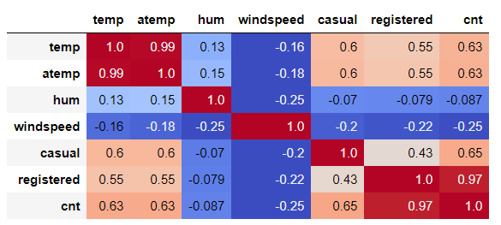

Color dark blue indicates there is strong positive relationship and if darkness is decreasing indicates relation between variables are decreasing.
Color dark Red indicates there is strong negative relationship and if darkness is decreasing indicates relationship between variables are decreasing.

2.2.3.1 Dimensionality Reduction for numeric variables
Above Fig 2.7 is showing
there is strong relationship between independent variables ‘temp’ and ‘atemp’ so considering any one feature enough to predict.
And it is also showing there is almost no relationship between independent variable ‘hum’ and dependent variable ‘cnt’. so, ‘hum’ is not so important to predict.
Subsetting two independent features ‘atemp’ and ‘hum’ from actual dataset.

2.2.4 Features Scaling

The word “normalization” is used informally in statistics, and so the term normalized data can have multiple meanings. In most cases, when you normalize data you eliminate the units of measurement for data, enabling you to more easily compare data from different places. Some of the more common ways to normalize data include:
Transforming data using a z-score or t-score. This is usually called standardization. In the vast majority of cases, if a statistics textbook is talking about normalizing data, then this is the definition of “normalization” they are probably using.
Rescaling data to have values between 0 and 1. This is usually called feature scaling. One possible formula to achieve this is.

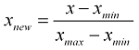

In rental dataset numeric variables like ‘temp’, ‘atem’,’hum’ and ‘windspeed’ are in normalization form so, we have to Normalize two variables ‘casual’ and ‘registered’
After normalize ‘casual’ and ‘registered’ variables look like in table below where all values between 0 and 1

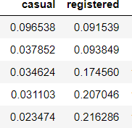

Chapter 3

Modeling

3.1 Model Selection

In our earlier stage of analysis, we have come to understand that few variables like ‘temp’, ’casual’, ’registered ‘are going to play key role in model development, for model development dependent variable may fall under below categories
- Nominal
- Ordinal
- Interval
- Ratio
In our case dependent variable is count so, the predictive analysis that we can perform is Regression Analysis
3.1.1 Evaluating Regression Model
The main concept of looking at what is called residuals or difference between our predictions f(x[I,]) and actual outcomes y[i].
We are using two methods to evaluating performance of model
- MAPE: (Mean Absolute Percent Error) measures the size of the error in percentage terms. It is calculated as the average of the unsigned percentage error.

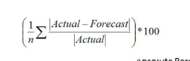

- RMSE: (Root Mean Square Error) is a frequently used measure of the difference between values predicted by a model and the values actually observed from the environment that is being modelled.

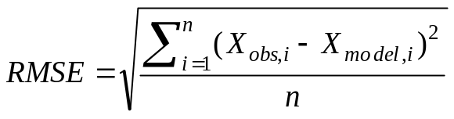

3.2 Decision Tree
A tree has many analogies in real life, and turns out that it has influenced a wide area of machine learning, covering both classification and regression. In decision analysis, a decision tree can be used to visually and explicitly represent decisions and decision making. As the name goes, it uses a tree-like model of decisions.

Figure 3.2.1 Decision Tree Algorithm
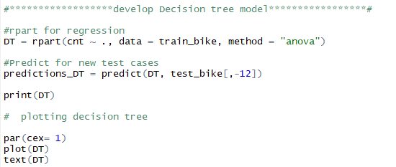
Figure 3.2.2 Graphical Representation of Decision tree

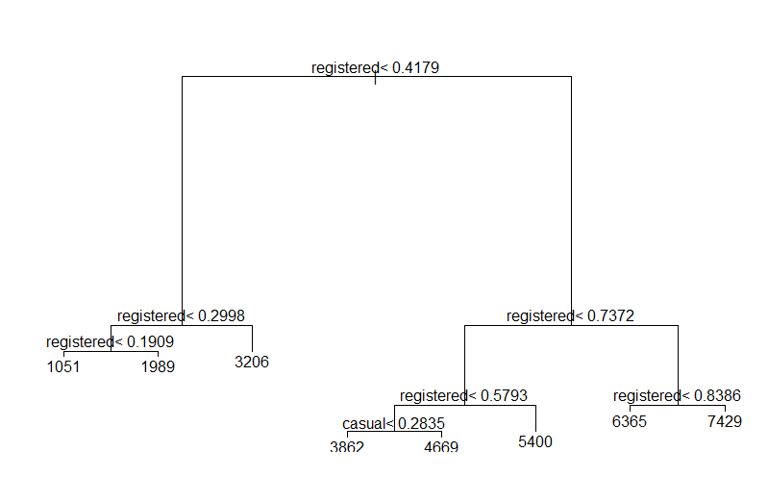

above figure 3.2.2 indicating that decision tree is using only two predictors variables to predict the model, which is not very impressive here the model is overfitted and biased towards only two predictors i.e ‘casual’ and ‘registered’.

3.3 Random Forest
Random forests or random decision forests are an ensemble learning method for classification, regression and other tasks, that operate by constructing a multitude of decision trees at training time and outputting the class that is the mode of the classes (classification) or mean prediction (regression) of the individual trees. Random decision forests correct for decision trees' habit of overfitting to their training set.

Random forest functions in below way
- Draws a bootstrap sample from training data.
- For each sample grow a decision tree and at each node of the tree
- Randomly draws a subset of mtry variable and p total of features that are available
- Picks the best variable and best split from the subset of mtry variable
- Continues until the tree is fully grown.

As we saw in section 3.2 Decision tree is overfitting and its accuracy MAPE and RMSE is also poor in order to improve the performance of the model developing model using Random Forest.
Figure 3.3.1 Random Forest Implementation

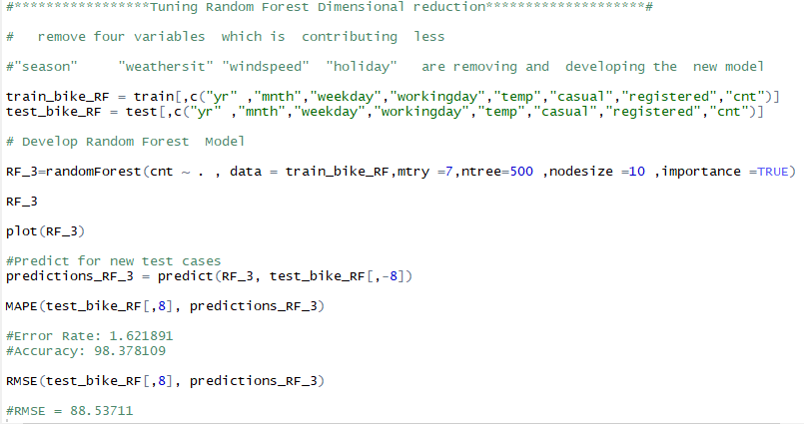

Mtry: Number of variables to split at each node i.e. 7.
Node size: size of each node is 10
Random Forest model is looking quite good where it utilized maximum variables to predict the count values

3.3.1 Evaluation of Random Forest
Figure 3.2.2 Random Forest Evaluation
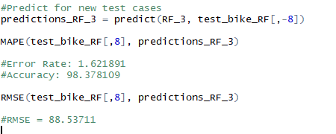

Fig 3.2.2 shows Random Forest model performs dramatically better than Decision tree on both training and test data and well also improve the Accuracy (MAPE = 1.621891) and decrease the RMSE (88.53711) of the model which is quite impressive.
Using Linear Regression, we will predict the ‘cnt ‘values and compare with Random Forest.

3.4 Linear Regression
Multiple linear regression is the most common form of linear regression analysis. As a predictive analysis, the multiple linear regression is used to explain the relationship between one continuous dependent variable and two or more independent variables. The independent variables can be continuous or categorical.
VIF (Variance Inflation factor): It quantifies the multicollinearity between the independent variables.
As Linear regression will work well if multicollinearity between the Independent variables are less.

Figure 3.4.1 Multi collinearity between Independent variables

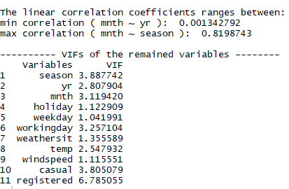

In the above figure it is showing there is strong correlation between two independent variables ‘mnth’ and ‘season’ so, it is enough to consider any one variable.

Figure 3.4.2 Multiple Linear Regression Model

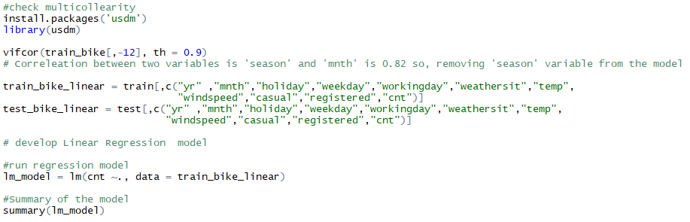

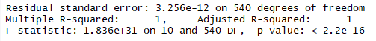
Here:
Residual standard error: 3.256e-12 on 540 degrees of freedom
Multiple R-squared: 1, Adjusted R-squared: 1
Here residual Standard error is quite less so the distance between predicted values f(x[I,]) and actual values f(x) are very less so this model is predicted almost accurate values.
And Multiple R-Square value is 1 so, we can explain about 100 % of the data using our multiple linear regression model.

3.4.1 Evaluation of Linear Regression Model

Figure 3.4.3 Evaluation of Regression Model

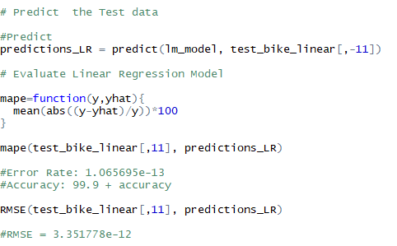

From above figure it is clearly showing that Model Accuracy is 99.9 %

Model Selection
As we predicted counts for Bike Rental using three Models Decision Tree, Random Forest and Linear Regression as MAPE is high and RMSE is less for the Linear Regression Model so conclusion is

Conclusion: - For the Bike Rental Data Linear Regression Model is best model to predict the count.
Appendix A - R Code

Fig 2.1 and 2.2 R Code

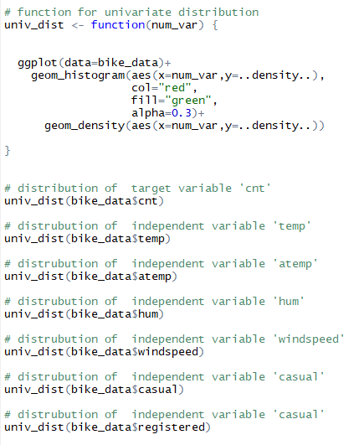

Fig 2.3 R Code

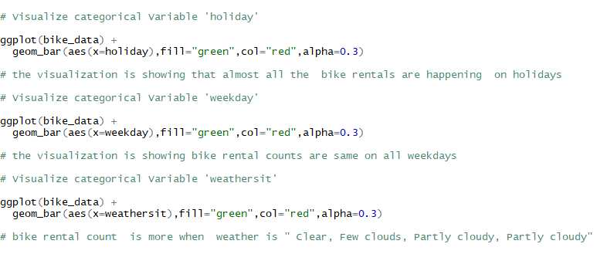

Fig 2.4 R Code

Fig 2.5 & 2.6 R Code
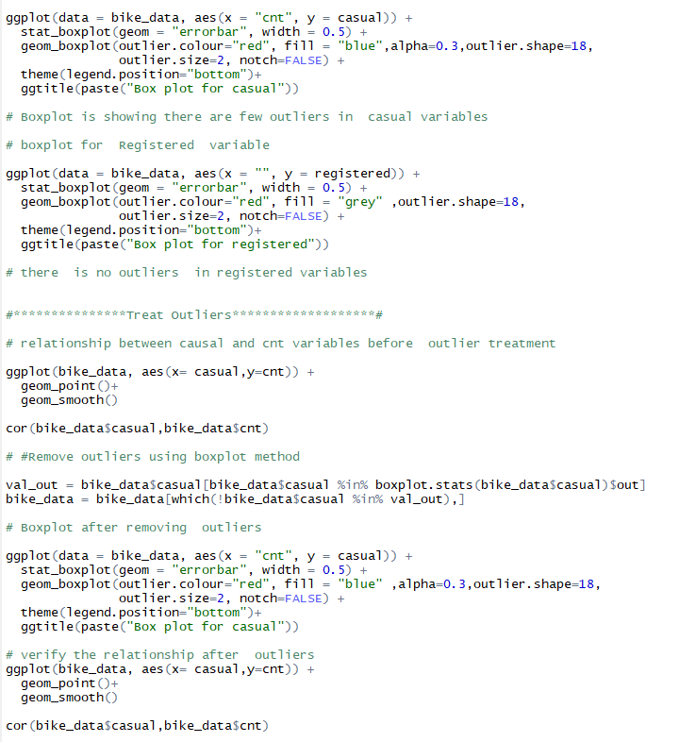

Complete R Code
